**Digital Storage Oscilloscopes (DSO)**

<https://www.alibaba.com/product-detail/Hot-Sale-Bandwidth-50MHZ-Digital-Handheld_60394361605.html?spm=a2700.galleryofferlist.normal_offer.d_image.1cfb2708zRPTnG>

**Price :** >= 1 piece US$250.00

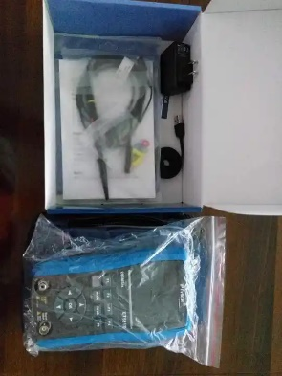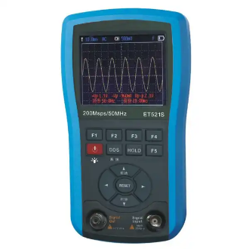

**Product Name:** GAOTek Digital Handheld Storage Oscilloscope

**Product ID:** GAOTek-DSO-101

**Overview:** GAOTek digital handheld storage oscilloscope 50M digital storage oscilloscope (DSO).10Hz~156kHz function signal generator (DDS).Digital/analog clock and calendar display. Help window to prompt key functions and measurement items.DSO realizes one-click (AUTO) automatic measurement.Automatic display of measured waveforms and automatic zero correction.Digital readout of Vp-p, +Vp,-Vp, f, T, dV and dt and measurement setting parameters.Memory or readout of up to 40 DSO waveforms.Generate sine wave, triangular wave, sawtooth wave and square wave signals, used in conjunction with oscilloscope function to compose a test system.Use internal 200μS/400μS to test square waves, facilitate the detection of HOT type inter-turn faults ringing signal.Auto shutdown and continuous work modes to choose from, automatically select continuous work mode during charging.320X240 3.5-inch color LCD display with LED backlight.Built-in 2300mAh lithium rechargeable battery pack and equipped with AC power supply adapter externally

**Technical Specifications:**

|  |  |
| --- | --- |
| Display | 320 ´ 240 dot matrix graphic color LCD |
| Backlight | White |
| Continuous service time | About 120 minutes |
| Battery | Built-in 2300mAh lithium battery pack |
| View area | (70 mm x 53mm) |
| Auto shutdown | 10 minutes |
| Charge time | More than 4 hours |
| Storage capacity | 40 groups of waveform records |
| Power supply adaptor | 110 V to 250 V, 5V/1.5A, protection switching power supply |
| Storage conditions | 14 °F to140 °F (-10 °C to +60 °C); <90% RH |
| Application environment | 32 °F to 104°F (0 °C to +40 °C); <75%RH |
| Dimensions | 7.87 in x 5.31 in x 2.04 in  ( 200 mm x 135 mm x 52 mm) |
| Weight | 0.49 kg (490 g) (excluding other accessories) |

[**https://www.alibaba.com/product-detail/Cleqee-2-CDS6012H-100MHz-Bandwidth-2_62466420220.html?spm=a2700.galleryofferlist.normal_offer.d_image.5dd62708ofkNU2**](https://www.alibaba.com/product-detail/Cleqee-2-CDS6012H-100MHz-Bandwidth-2_62466420220.html?spm=a2700.galleryofferlist.normal_offer.d_image.5dd62708ofkNU2)

**Price :** 1 to 49 piece US$65.00

>= 50 to 99 piece US$63.00

>= 100 piece US$60.00

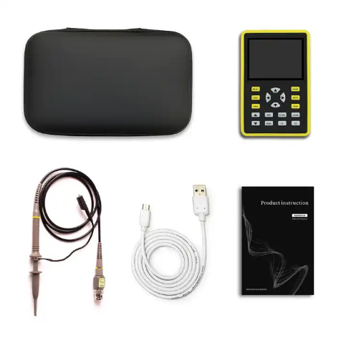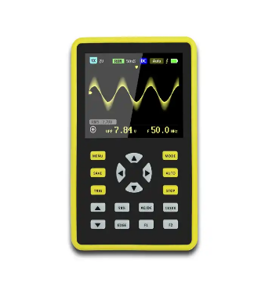

**Product Name:** GAOTek Waveform Storage Analog Digital Oscilloscope

**Product ID:** GAOTek-DSO-102

**Overview:** GAOTek Waveform Storage Analog Digital Oscilloscope is a versatile, highly practical, cost-effective handheld oscilloscope for the maintenance industry and the R&D industry with Cleqee's real-time sampling rate of up to 500MS/s and 100MHz analog bandwidth.With full trigger function (single, normal, automatic), it can be used freely for both periodic analog signals and non-periodic digital signals. The built-in high voltage protection module can  withstand  up to 400V continuous voltage and 600V peak voltage. There is no need to worry about the oscilloscope burnout caused by the high voltage not being probed to the 10X position.Large time base scan mode that monitors slow level changes. Equipped with high-efficiency one-button AUTO, the measured waveform can be displayed without complicated adjustment. Display high-definition LCD screen with 2.4-inch 320*240, the visual effect is very good. Extremely convenient and fast waveform storage function, built-in 64M storage space, can store up to 2000 waveform pictures, the storage process is simple and fast, save the current waveform anytime and anywhere, just one touch, no cumbersome tips and choices. Powerful waveform file manager, support for thumbnail browsing, viewing, detail viewing, page turning, deletion and more. Built-in 3000mah high-quality lithium battery, can be used continuously for 8 hours when fully charged.The body is equipped with high-quality silicone protective cover, non-toxic and lead-free environmental protection, anti-skid, anti-shock and shockproof, comprehensive protection of the fuselage, soft texture, feel very comfortable.

**Features:**

* Intelligent anti-burn,1X Can withstand up to 600 V withstand voltage
* Afterglow display technology
* 2.4 in color display screen
* One-button waveform storage
* Built-in 64M storage space, the maximum storage of 2000 waveform pictures
* Powerful waveform file manager, support thumbnail browsing, viewing, details view, flip, delete and other functions
* High measurement voltage range, 1X can measure 0 to 80 V, 10X can measure 0 to 800 V
* Up to 12 parameters measurement:VPP,VP,Vmax,Vmin,Vavg,Vrms,Frequent,Duty+,Duty-,Time+,Time-,Time
* At any time, the waveform display (pause function) is frozen
* Equipped with high efficiency One-button AUTO
* Complete triggering function (single, normal, automatic)
* Built in 3000 mAh rechargeable lithium battery,Fully charged for 12 hours of continuous use
* Screen brightness adjustment
* Memory compression technology, waveform refresh screen does not flicker
* Anti-slip anti-drop silicone sleeve
* Ultra small volume, easy to carry

**Technical Specifications:**

|  |  |
| --- | --- |
| Channels | 1 |
| LCD size | 2.4 inch |
| Bandwidth | 100MHz |
| Sampling Rate | 500MS/s |
| Rise time | < 3 ns |
| Storage depth | 128 kB |
| Time base | 50 S to 6 ns |
| Sensitivity | 50 mV to 200 V |
| Charging | 5 V / 1 A / 2 A / 3 A |
| Dimensions | 4.48 in x 2.91 mm x 1.29 mm (114 mm x 74 mm x 33 mm) |

<https://www.alibaba.com/product-detail/Huazheng-Electric-one-channel-50MHZ-Reasonable_60814919845.html?spm=a2700.galleryofferlist.normal_offer.d_image.66a12708UeZhdN>

**Price:** >=20 pieces US$200.00 to US$400.00

**Product Name:** GAOTek Hand-held Digital Storage Portable Oscilloscopes

**Product ID:** GAOTek-DSO-103

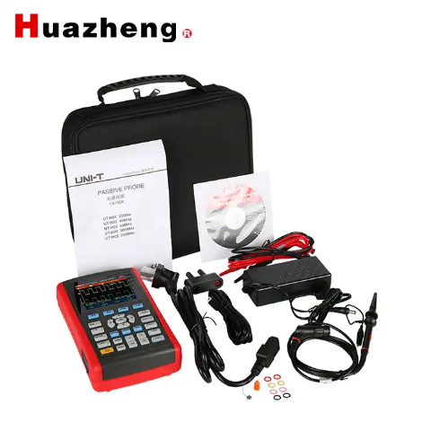

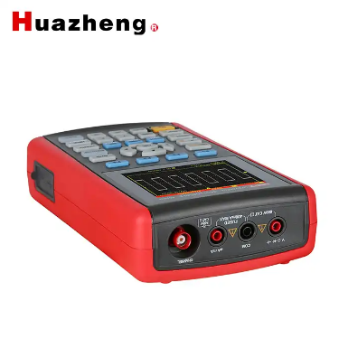

**Meta Description:** This GAOTek Hand-held Digital Storage Portable Oscilloscopes has a one channel 50MHZ, a sample rate of 200 MS/s and timebase range 5 ns/div~50 s/div.

**Features:**

* Fully time-based automatically auto scale
* Unique and powerful auto setup, quick and accurate to set up for signals with any DC component
* Wider voltage measuring range; coupled with 10×probe with attenuation up to 200 V/div
* Isolated USB for much safer communication
* White and black display for your option, perfect for use outdoor with strong light
* Intelligent localor network software update
* More than 8 hours of continuous battery operation

**Technical Specifications:**

|  |  |  |
| --- | --- | --- |
| **Channels** | | 1 |
| **Bandwidth** | | 50 MHz |
| **Sample Rate** | | 200 MS/s |
| **Rise Time** | | ≤7 ns |
| **Memory Depth** | | 12 kpts |
| **Vertical Sensitivity** | | 5 mV/div~20 V/div |
| **Timebase Range** | | 5 ns/div~50 s/div |
| **Storage** | | Bitmap, Setup, Waveform |
| **Trigger Modes** | | Edge, Pulse, Video, Slope |
| **Interface** | | Mini USB |
| **Multimeter Specifications** | | Range |
| **DC Voltage (V)** | | 400.0 mV/ 4.000 V/ 40.00 V/ 400.0 V |
| **AC Voltage (V)** | | 400.0 mV/ 4.000 V/ 40.00 V/ 400.0 V |
| **DC Current (A) (External Convertor)** | | 400.0 μA/ 4000 μA |
| 40.0 mA/ 400 mA |
| 10 A |
| **AC Current (A)**  **(45Hz~400Hz) (External Convertor)** | | 400.0 μA/ 4000 μA |
| 40.0 mA/ 400 mA |
| 10 A |
| **Resistance (Ω)** | | 400.0Ω/4.000kΩ/40.00 kΩ/400.0 kΩ/4.000 MΩ |
| 40.00 MΩ |
| **Capacitance (F)** | | 51.20 nF/512.0 nF/5.120 μF/51.20 μF/100 μF |
| **Display Count** | | 4000 |
| **Gross Weight** | 23.80 lb (10.8 kg) | |

<https://www.alibaba.com/product-detail/Digital-Storage-Osiloscopio-Analog-Touch-Screen_1600434513425.html?spm=a2700.galleryofferlist.normal_offer.d_image.114f2708Jw8HZu>

**Price:** >= 2 pieces US$80.00 to US$110.00

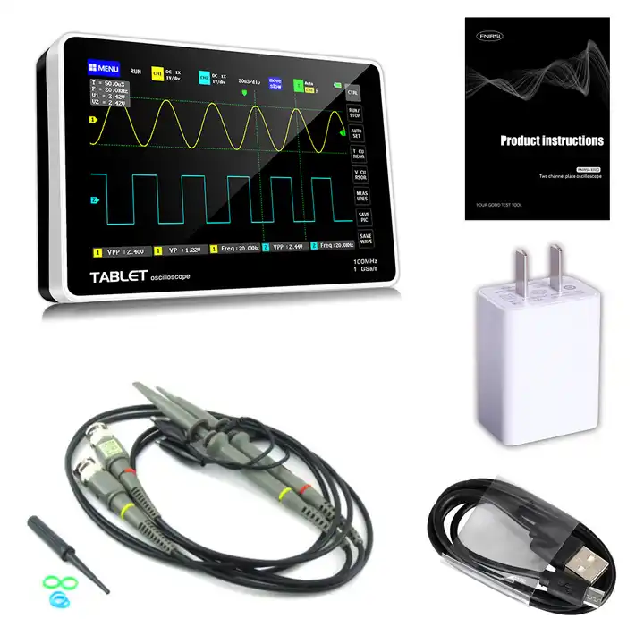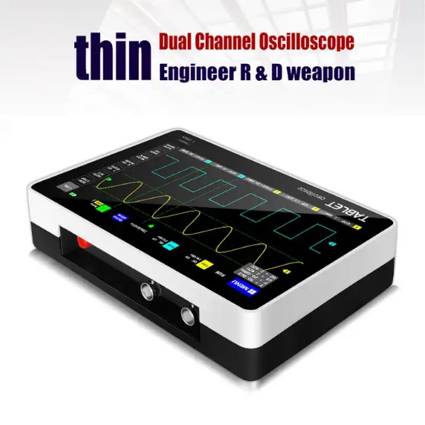

**Product Name:** GAOTek Touch Screen Analog DSO

**Product ID:** GAOTek-DSO-104

**Overview:**  GAOTek Touch Screen Analog DSO is a full-featured. highly practical, cost-effective dual-channel flat-panel oscilloscope for the maintenance and R & D industry; this oscilloscope has a real-time sampling rate of 1GSa / s and an analog bandwidth of 100MHz * 2 . With complete trigger function (single / normal / automatic). it can be used freely for periodic analog signals or non-periodic digital signals; the built-in high-voltage protection module can tolerate a continuous voltage of up to 400V. Oscilloscope burnout accident caused by the probe being turned to the 10X position. Large time base scroll mode can monitor slow level changes: Equipped with highly efficient one-key AUTO, which can display the measured waveform without tedious adjustments: the display is equipped with a 7-inch  
800 * 480 resolution high-definition LCD LCD screen, and the operation method is capacitor Screen touch + gesture operation, extremely convenient: cursor measurement function, you do not need to read the background scale unit and quantity when manually reading the amplitude and frequency parameters, and you can directly get the peak. peak and frequency without conversion;  
extremely convenient screenshot And waveform storage function. built-in 1GB storage space. can store up to 1000 screenshots + 1000 sets of waveform data. the storage process is simple and fast. save the current waveform anytime. anywhere with a single touch, no  
cumbersome prompts and choices. keep calm The current data is saved in the place, which is very convenient: the powerful waveform picture manager supports thumbnail browsing. viewing，detailed viewing， page turning. deletion and waveform zooming in, zooming  
out, moving. etc.. to facilitate secondary analysis. The fuselage is equipped with a USB interface, which can be connected to a computer to share its screenshots with the computer, which is convenient for secondary analysis; Li Shayu's graphic display function can be used to determine the amplitude. Frequency and phase contrast of two groups of signals; Analysis of the harmonic components of the signal; built-in 6000mah high-quality lithium battery. which can last for 4 hours on a full charge. and can be  
used while charging like a notebook

**Technical Specifications:**

|  |  |
| --- | --- |
| item | value |
| Customized support | OEM, ODM |
| Channels | 2 Channels |
| Bandwidth | 100 MHz |
| Color | Black |
| size | 0.7 in x 0.53 in x 0.19 in  (20x13x5) cm |
| weight | 2.20 lb (1.000 kg) |

<https://www.alibaba.com/product-detail/FNIRSI-1C15-Digital-Oscilloscope-500MS-S_1600535922728.html?spm=a2700.galleryofferlist.normal_offer.d_image.114f2708Jw8HZu>

**Price:** >= 1 to 99 pieces US$65.00

>=100 to 999 pieces US$60.00

>= 1000 pieces US$55.00

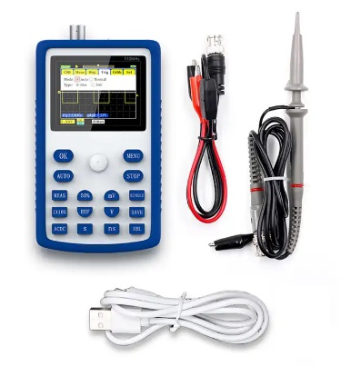

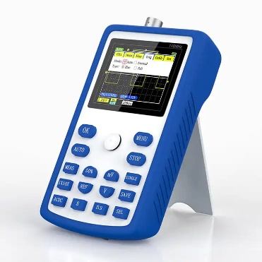

**Product Name:** GAOTek Portable Oscilloscope

**Product ID:** GAOTek-DSO-105

**Overview:**

GAOTek Portable Oscilloscopeis a fully functional, strong practicality, for maintenance, a cost-effective oscilloscope for R&D and education industries. Made of fine quality material, practical, easy to operate and use, has a long service life. Come on and try it.

**Features:**

* Lightweight and compact design
* 110MHz bandwidth, 500MS/s sampling rate, ±400V measuring voltage
* Durable materials for long service life
* Waveform functions: move, expand, save, lock
* Infinite persistence mode for capturing occasional waveforms
* Comprehensive trigger modes for different signal types
* One-key auto-adjustment for easy setup
* FPGA+ADC(MCU) design for stable performance and higher accuracy
* 14 waveform measurements available
* Small, shockproof, and drop-proof
* Wide range of applications: home appliance testing, car diagnosis, research, education, product development

**Technical Specifications:**

|  |  |
| --- | --- |
| Channel coupling | AC/DC |
| Time base range | 5 ns |
| Single trigger | support |
| Numbers of channels | 1 |
| One key automatic | support |
| Vertical sensitivity | 20 mV/div |
| 50%/back to middle | support |
| Screen size | 2.4 inch |
| Waveform measurement | 14 types |
| Trigger mode | auto/normal/single |
| Operation mode | button+joystick |
| Screen resolution | 320 x 240 |
| Measurement accurancy | ±2% |
| Trigger type | rising edge/falling edge |
| Waveform analysis | support drag/expand |
| Analog brandwidth | 110 M |
| Display mode | YT/scroll |
| Sampling rate | 500 M |
| Waveform save | support |
| Afterglow time | none/1s/∞ |
| Rise time | <3 ns |
| Frequency accurancy | ±0.01% |
| Charging method | 5 V/800 mA |
| Battery | 1 * lithium battery,3000mAh |
| Storage depth | 12 kpts |
| Input resistance | 1 MΩ |
| Voltage measurement range | ±40 V(*1 file), ±400 V(*10 file) |
| Item size | 5.1 x 3.0 x 1.1in (130 x76 x 27mm ) |
| Package size | 5.3 in x 3.7 in x 2.2 in (134 mm x 94 mm x 56 mm ) |
| Package weight | 340g / 12.0ounce |

<https://www.alibaba.com/product-detail/allsun-EM115A-Oscilloscope-50MHZ-Handheld-Oscillograph_62319876279.html?spm=a2700.galleryofferlist.normal_offer.d_image.69eb2708Ljrnll>

**Price:** >= 2 pieces US$182.30

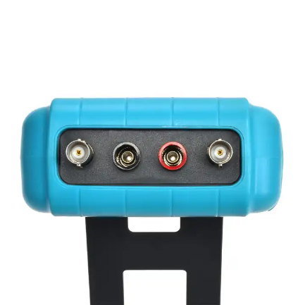

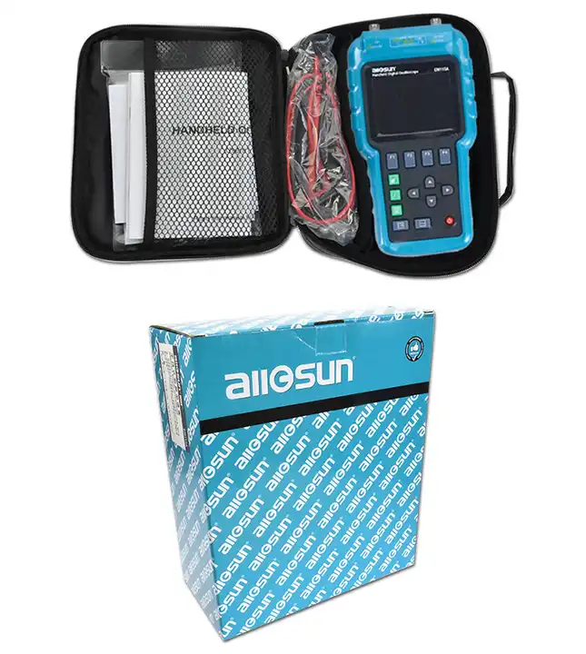

**Product Name:** GAOTek creen Scope meter Single Channel DSO

**Product ID:** GAOTek-DSO-106

**Overview:**

The oscilloscope features compactness,beautiful appearance and friendly interfaces.It can quickly and accurately detect the faults of the circuit under test and can serve as an electronic engineer's assistant, and will provide great convienience for you in work.

**Technical Specifications:**

|  |  |
| --- | --- |
| Bandwidth (-3dB) | 50 MHz |
| Sampling Rate | Max. real time sampling rate 200 MSa/s |
| Channel | 1 |
| Coupling | AC, DC |
| Rise Time | </=7.6ns |
| Input Impedance | 1 MΩ, < to = 20 pF |
| Max Input Voltage | 1x CAT III 300 VAC 10x, 100x CAT III 600 VAC |
| Vertical Resolution | 8 bit |
| Vertical Sensitivity | 10 mV/div to 5 V/div |
| Horizontal Resolution | 2 ns/div |
| Horizontal Sensitivity | 2 ns to 5 s |
| Record Length | 4K/channel |
| Memory | 6 memory locations |
| Trigger Mode | Auto, Normal, Single |
| Trigger Type | Edge trigger |
| Screen | 320×240 pixels (RGB), with LED backlight |
| Battery | 3.7 V lithium polymer battery, 4 Ah |
| Adapter | Input Voltage: 100 Vac to 240 Vac    Output:   5 Vdc +/- 10%, 2000 mA |
| Operating Environment | Temperature:   32 **°**F to 104 **°F**(0 ℃ to 40 ℃) |
| Humidity:  </=75% |
| Storage Environment | Temperature: 14 **°**F to 122 **°**F ( -10 ℃ to 50 ℃) |
| Humidity:  </= 85% |
| Operating Altitude | 0 ft to 6561.68 ft  (0 m to 2000 m) |
| Display | 6000 counts |
| Input | Max. Input Voltage: 600 Vrms CAT II, 300 Vrms CAT III |
| Continuity Test | Beeps at < 25 Ohm, in 600 Ohm range |
| Diode Test | If the voltage drop of the diode under test is more than 2 V or if the test circuit is open, the display will show " OL ".  If the voltage drop is less than 0.25 V, the built-in buzzer will sound. |
| Capacitance Measurement | 6.000 nF to 6 mF |
| Resistance Measurement | 600.0 Ohm to 60.00 M Ohm |
| Voltage Measurement | 6.000 V to 600 V |
| Humidity | </= 85% |
| Storage Environment | Temperature: 14 **°**F to 122 **°**F ( -10 ℃ to 50 ℃) |
| Size | 8.58 in x 4.46 in x 1.96 in (218 mm × 118 mm × 50 mm) ( including holster ) |
| Weight | 1.54 lb (0.7 kg ) |

<https://www.alibaba.com/product-detail/ZEEWEII-DSO2512G-2-8-Inch-120M_1600776889146.html?spm=a2700.galleryofferlist.normal_offer.d_image.69eb2708Ljrnll>

**Price:** >=1 to 99 pieces US$76.99

>= 100 to 499 pieces US$73.99

>= 500 to 1999 pieces US$70.99

>= 2000 piecesUS$67.99

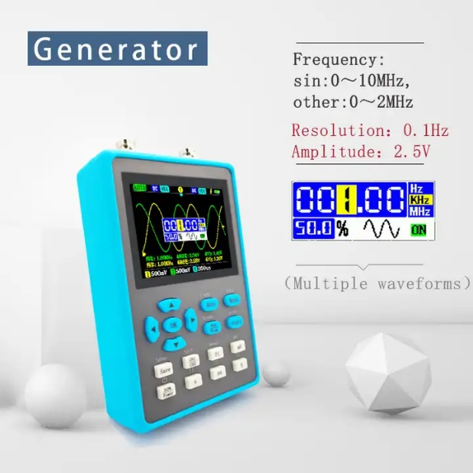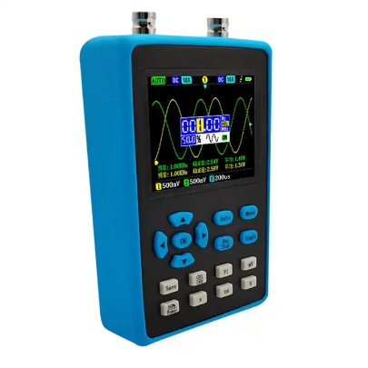

**Product Name:** GAOTek Signal Generator XY Mode Handheld Digital Oscilloscope

**Product ID:** GAOTek-DSO-107

**Overview:**

This GAOTek Signal Generator XY mode Handheld Digital Oscilloscope 120M bandwidth oscilloscope with powerful functions, like adopt ARM and FPGA chip collocation, also can output Various waveforms of 2.5V amplitude such as sine waves, half waves and so on. Come on and try it, it will not let you down.

**Features:**

* ARM and FPGA for fast signal processing
* Versatile applications: debugging, maintenance, DIY, electronic competition
* Bottom output for 2.5V amplitude waveforms (sine, square, triangle, etc.)
* Frequency adjustment: Sine wave (0-10MHz), other waveforms (0-2MHz)
* 14 measurements: Frequency, Peak to Peak, Duty cycle, Amplitude, RMS, Average, Period, +Pulse width, -Pulse width, Max, Min, Top, Base, -Duty cycle

**Technical Specifications:**

|  |  |
| --- | --- |
| Channels | 2 |
| Coupling | AC/DC |
| Precision of V | ±2% |
| Bandwidth | 120 M(ch1 only)dual channel mode is 60M |
| **Sampling rate** | 500 M |
| **Rise time** | <3 ns |
| **Frequency** | ±0.01% |
| **Impedance** | 1 MΩ |
| **FFT** | support |
| **Time base** | 5 ns to10 s |
| **Wave out amp** | 2.5 V |
| **Ver sensitivity** | 10 mV/div to10 V/div |
| **Waves out freq** | 10 MHz(sin) 2 MHz(other) |
| **Max voltage** | ±40V(x1), ±400V(x10) |
| **Trigger type** | rise/fall |
| **Display mode** | YT/Roll |
| **Persistence** | None/1s /∞ |
| **Battery** | 1 * lithium battery, 4000 mAh (included) |

<https://www.alibaba.com/product-detail/ET826-2-In-1-Digital-Oscilloscope_1600503983434.html?spm=a2700.galleryofferlist.normal_offer.d_image.611d27>

**Price:** >=10 to 99 piecesUS$52.00

>=100 to 199 pieces US$51.00

>= 200 pieces US$50.00

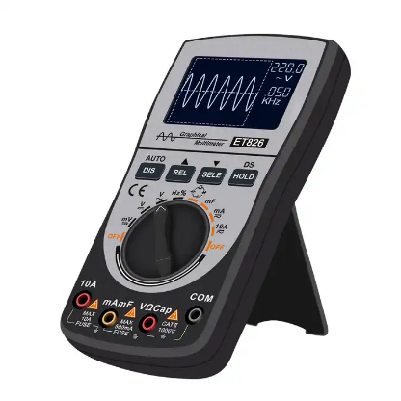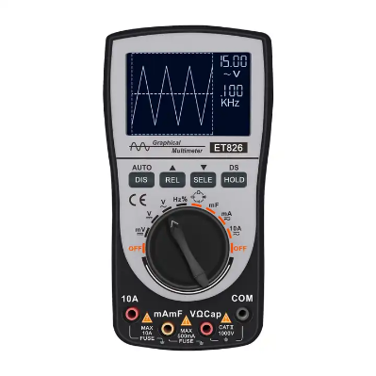

**Product Name:** GAOTek Digital Oscilloscope Multimeter

**Product ID:** GAOTek-DSO-108

**Meta Description:** This GAOTek Digital Oscilloscope Multimeter has a Measuring Voltage Range 400 mV to 4 V, a Measuring Current Range 40 mA to 400 mA and LCD size 2.36 in x 1.57 in .

**Technical Specifications:**

|  |  |
| --- | --- |
| **Measuring Current Range** | 40 mA to 400 mA, 4 A to10 A |
| **Measuring Voltage Range** | 400 mV to 4 V to 40 V/400 V to 1000 V |
| **Measuring Resistance Range** | 400 Ω/4 KΩ/40 KΩ/400 KΩ/4 MΩ/40 MΩ |
| **Measuring Capacitance Range** | 51.2 nF/512 nF/5.12 μF/51.2 μF/100 μF/10 mF |
| **LCD size** | 2.36 in x 1.57 in (60 mm x 40mm) |
| **waveform record** | 10 groups |
| **Analog bandwidth** | ACV/DCV/ACA/DCA 20KHz |
| **Frequency: Range** | 5Hz to 5MHz |
| **Maximum real-time sampling rate** | 200 ksps |
| **Package size** | 7.4 in x 5.51 in x 1.77 in (190 mm x 140 mm x 45mm) |
| **Package weight** | 0.79 lb (0.36 kg) |
| **Operating Temperature** | 32 **°**F to 104 **°**F (0 ℃ to +40 ℃) |
| **Dimensions** | 6.2 in x 3.26 in x 1.25 in (160 mm x 83 mm x 32mm) |
| **Item weight** | 0.41 lb (0.19 kg) |

<https://www.alibaba.com/product-detail/LW-2102CEL-100MHZ-Bandwith-2-Channel_62356246236.html?spm=a2700.galleryofferlist.normal_offer.d_image.611d2708MAeYa5>

**Price:** >= 1 to 9 pieces US$258.50

>= 10 to 99 pieces US$236.90

>= 100 units US$226.20

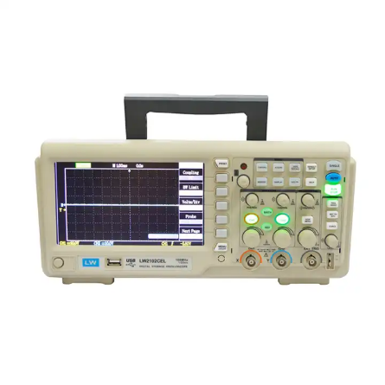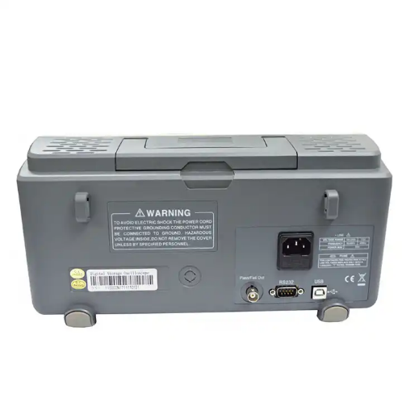

**Product Name:** GAOTek 2 Channel USB Oscilloscope

**Product ID:** GAOTek-DSO-109

**Meta Description:** This GAOTek Digital Oscilloscope Multimeter has a Measuring Voltage Range 400 mV to 4 V, a Measuring Current Range 40 mA to 400 mA and LCD size 2.36 in x 1.57 in .

**Features:**

* 1GSa/s Sampling rate
* 2 channels
* 7 Inches Wide screen LCD color display
* USB host/device:Support USB printer and USB flash drive
* Pctbridge function
* Easy-scope software
* ndustrial power design,troubleshooting,installation and maintenance.
* Electronic design,troubleshooting,installation and maintenance.
* Circuit design and debug
* Education lab and training institution
* Repair and service
* Production test and quality inspection

**Technical Specifications:**

|  |  |
| --- | --- |
| **Risetime** | ≤3.5 ns |
| **Sample Rate** | 1 GS/s |
| **Equivalent sampling rate** | 50 GS/s |
| **Sampling** | Sampling, peak detection, average |
| **Waveform capture rate** | ≥2000 wfms/s |
| **Vertical deflection system** | 1 mV to 20 V/div |
| **Wsiz** | 25 kpts |
| **The scanning time base** | 2 ns to 50 s/div |
| **Trigger Type** | Edge, pulse width, alternate |
| **Automatic measurement of waveform parameters** | 28 species |
| **Hardware frequency meter** | 6 bit trigger frequency meter |
| **Port** | USB OTG |
| **Mathematical value** | Add, subtract, multiply and divide,FFT |
| **Additional function** | Unique screen copy function |

[**https://www.alibaba.com/product-detail/TECPEL-OS-1022-2CH-Handheld-20MHz_407559126.html?spm=a2700.galleryofferlist.normal_offer.d_image.6a5c2708QUw3ol**](https://www.alibaba.com/product-detail/TECPEL-OS-1022-2CH-Handheld-20MHz_407559126.html?spm=a2700.galleryofferlist.normal_offer.d_image.6a5c2708QUw3ol)

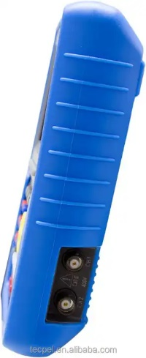**Price :** >= 1 piece US$500.00

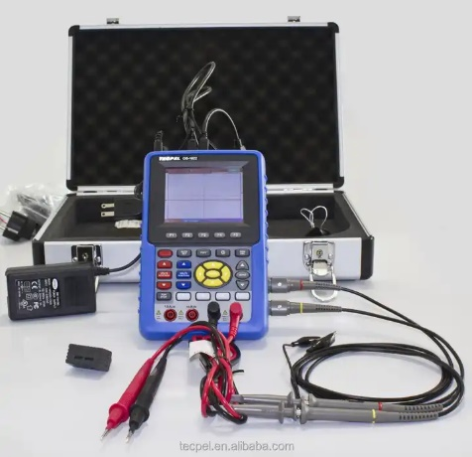

**Product Name:** GAOTek 20MHz Digital oscilloscope

**Product ID:** GAOTek-DSO-1010

**Overview :** This GAOTek 20MHz Digital oscilloscope with multifunctional electric meter and oscilloscope functions. With a multi-language interface, 20MHz measurement bandwidth can be used for electronic circuit inspection, suitable for school teaching and personal studio use.

**Technical Specifications:**

|  |  |  |
| --- | --- | --- |
| **Bandwidth** | | 20 MHz |
| **Sampling Rate** | | 100MS/s |
| **Rise Time** | | smaller than 17.8nS |
| **Horizontal Resolution** | | 5ns/div to 100s/div |
| **Vertical Resolution** | | 5mV/div to5V/div |
| **Memory Depth** | | Each Channel 6K |
| **Channel** | | 2 |
| **Maximum Input voltage** | | 400V(PK |
| **Sampling** | | ±100ppm |
| **Trigger Accuracy** | | ±0.3 div |
| **Input Resistance** | | 1M Ω±2%,Parallel with 20 pF±3 pF ) |
| **Display Digits** | | 3,999 |
| **AC Voltage** | | 750 V |
| **DC Voltage** | | 1,000 V |
| **AC Current** | | 40m / 4000m / 10 A |
| **DC Current** | | 40m / 4000m / 10 A |
| **Resistance** | | 400 / 4 K / 40 K / 400 K / 4 M /40M Ω |
| **Capacitance** | | 51.20 n / 512.0 n / 5.120 u / 51.20 u / 100 uF |
| **Power Supply** | Lithium battery |
| **Power Consumption** | Approx. 6W |
| **Working Environment** | 32 °F to 104 °F(0 °C to 40 °C / lower than 80%RH without dew |
| **Dimension** | 7.09 in x 4.5 in x 1.5 in (180mm × 115mm × 40 mm) |
| **Weight** | 1.49 lb (0.68 kg) |